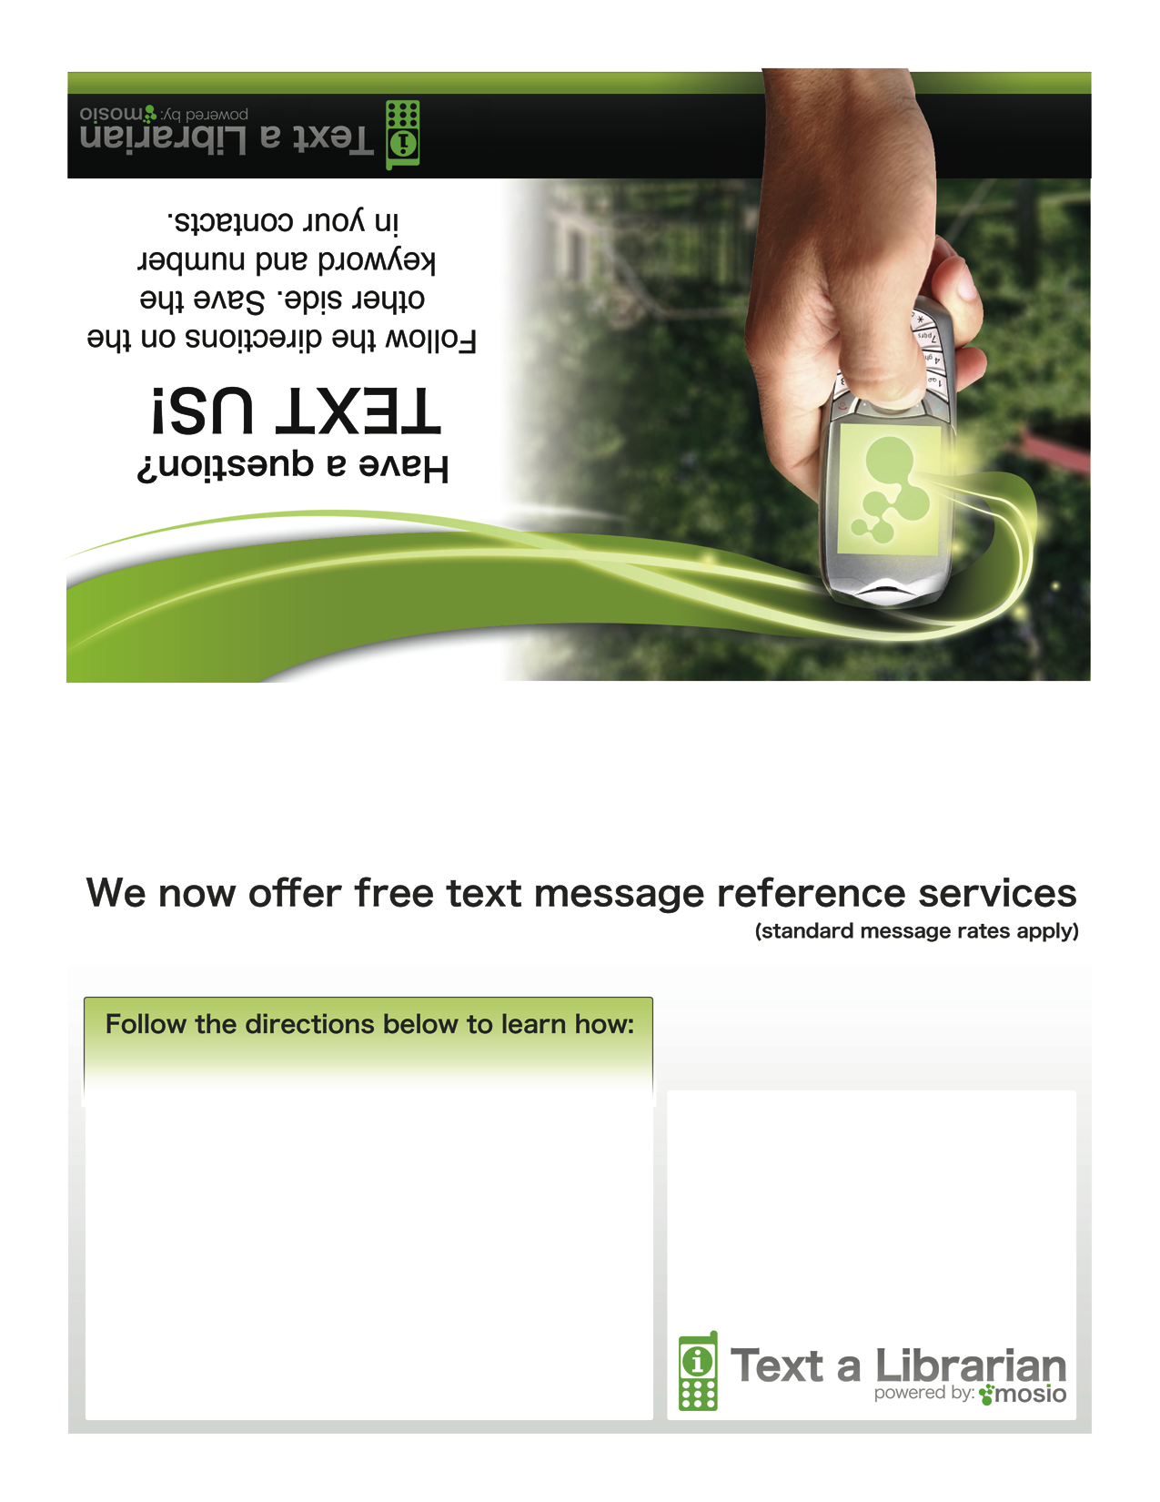

Text START to
XXX-YYY-ZZZZ
for instructions.
Library Logo or Name
HERE
(click here to
edit/delete text)

